**1. Display the details of employee whose salary is >=100000 and designation is ‘Ceo’.**

mysql> select * from emp

-> where salary>=100000 and designation='Ceo';

**Output:**

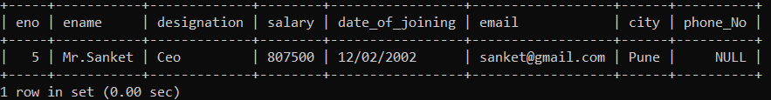

**2. Display the name of employee whose belongs to either ‘Pune’ or ‘Mumbai’.**

mysql> select ename from emp

-> where city='Pune' or city='Mumbai';

**Output:**

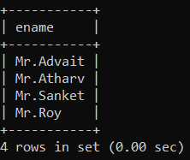

**3. Display the name of employee whose salary >= 50000 and having designation ‘Manager’ or ‘Ceo’.**

select ename from emp

-> where salary>=50000 and designation='Manager' or designation='Ceo';

**Output:**

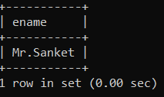

**4. Update salary of employee with 5% increment whose salary >= 50000 and phone_No is ‘1234567890’.**

mysql> update emp set salary=salary+(salary*0.05)

-> where salary>=50000 and phone_No='1234567890';

Query OK, 1 row affected (0.02 sec)

Rows matched: 1 Changed: 1 Warnings: 0

mysql> select * from emp

-> where phone_No='1234567890';

**Output:**

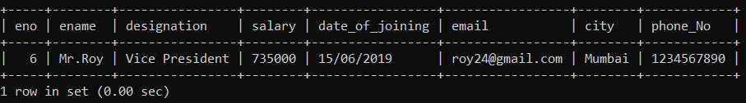

**5. Delete the details of employee whose eno=6.**

mysql> delete from emp

-> where eno=6;

Query OK, 1 row affected (0.02 sec)

**Output:**

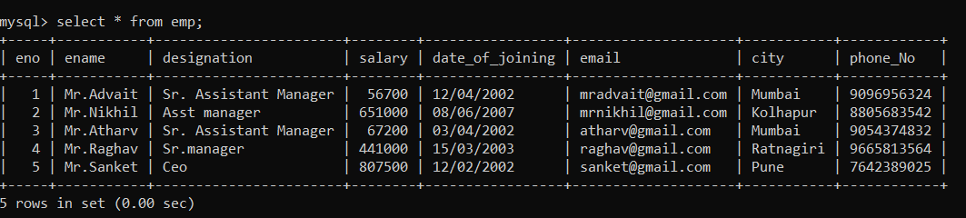

**6. Display unique city whose designation is Ceo.**

mysql> select city from emp

-> where designation='Ceo';

**Output:**

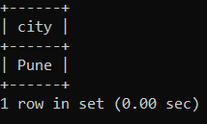

**7. Display the details of employee whose salary between 50000 to 100000 and city is Mumbai.**

mysql> select * from emp

-> where salary between 50000 and 100000 and city='Mumbai';

**Output:**

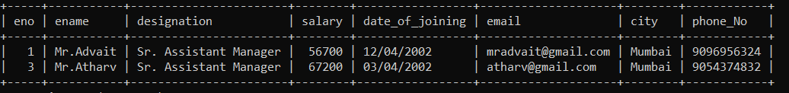

**8. Display details of employee where eno between 1 to 5 and his name is Mr.Advait.**

select * from emp

-> where eno between 1 and 5 and ename='Mr.Advait';

**Output:**

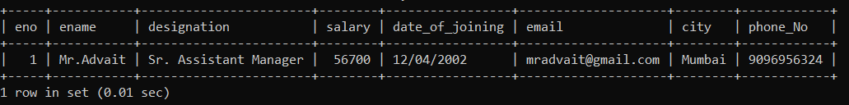

**9. Update city of employee to ‘Pune’ whose salary is between 50000 to 100000.**

mysql> update emp set city='Pune'

-> where salary between 50000 and 100000;

Query OK, 2 rows affected (0.03 sec)

Rows matched: 2 Changed: 2 Warnings: 0

**Output:**

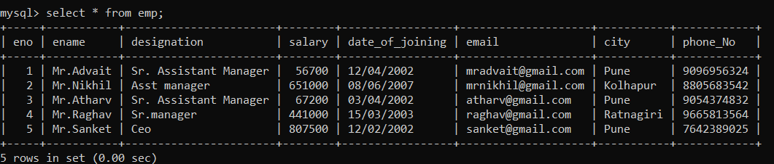

**10. Display ename of employees whose name start with ‘M’ and ends with ‘m’ & designation is Ceo & he/she belongs to Pune or Mumbai or Nagpur city.**

select ename

-> from emp

-> where ename like 'M%m' and designation='Ceo' and city in('Pune','Mumbai','Nagpur');

**Output:**

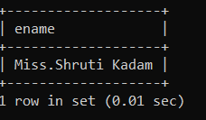

**11. Display the details of employee whose email contains ‘.’ character and salary between 10000 to 20000 or employee eno is either 1,12,31,49.**

mysql> select * from emp

-> where (email like '%.%') and (salary between 50000 and 70000) or (eno in(1,12,31,49));

**Output:**

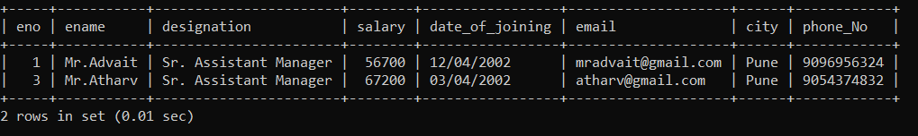

**12. Display ename, designation, and phone_No of employee whose name having fourth character is ‘r’ and ends with ‘v’ & also email having ‘@’ and ‘.’ character & phone_No >= 123456789.**

mysql> select ename,designation,phone_No from emp

-> where ename like '___r%v' and email like '%@%.%' and phone_No>='123456789';

**Output:**

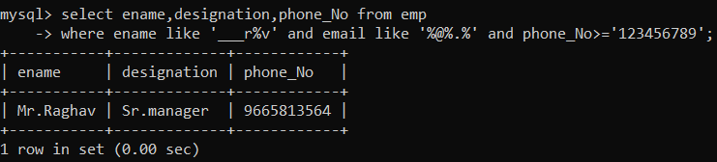

**13. Display the details of employee name in descending order whose name contains only nine characters.**

mysql> select * from emp

-> where ename like '_________'

-> order by ename desc;

**Output:**

